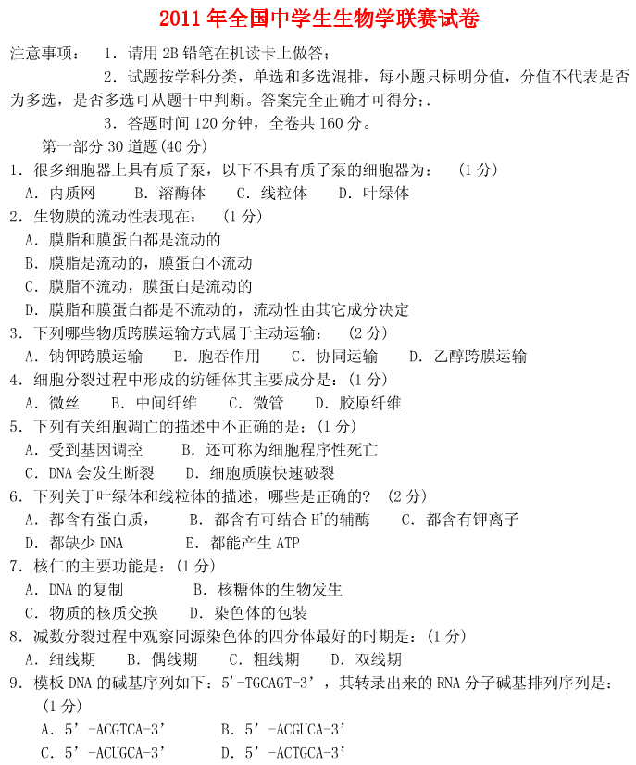

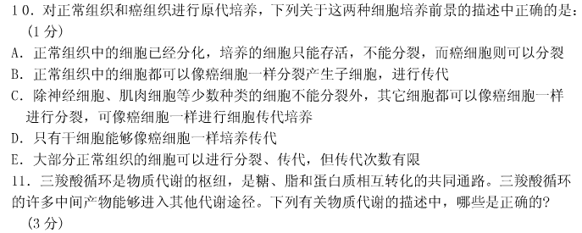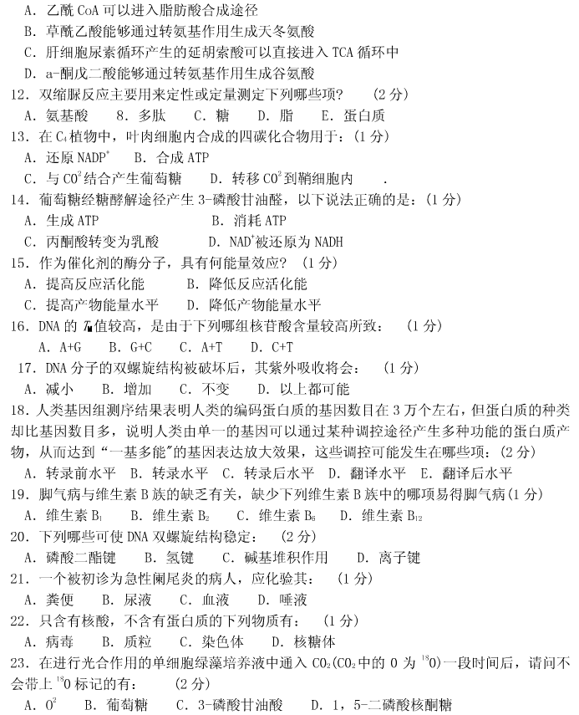

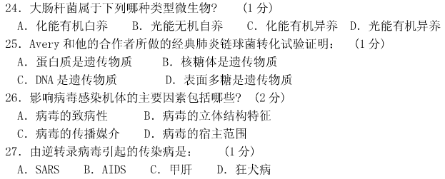

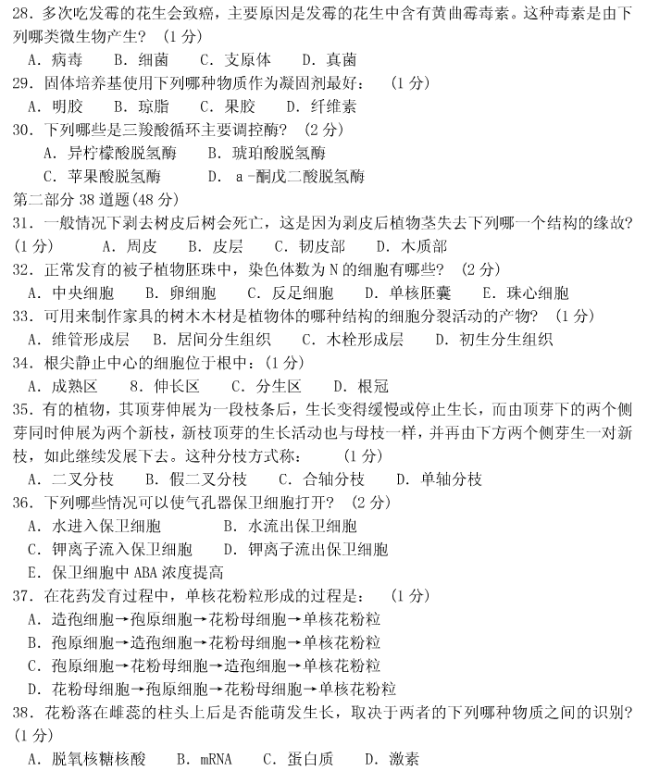

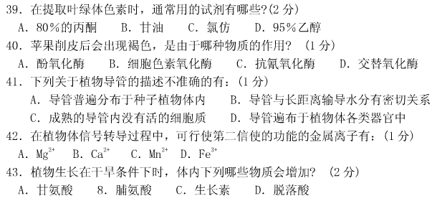

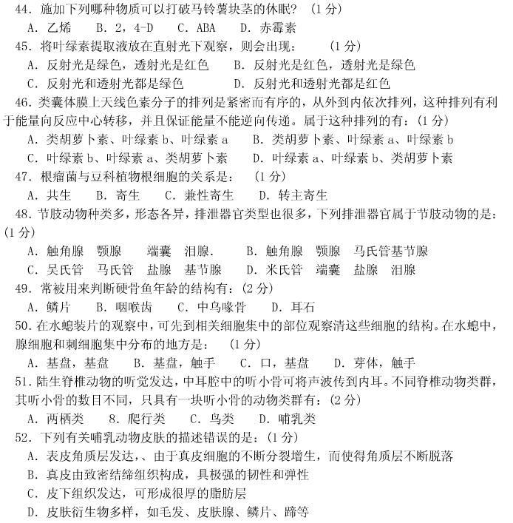

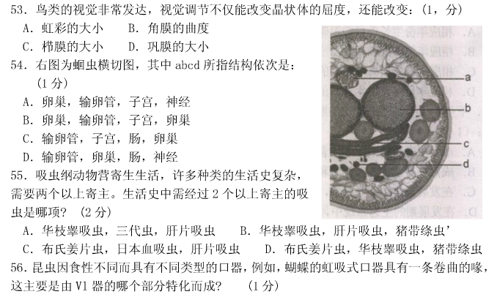

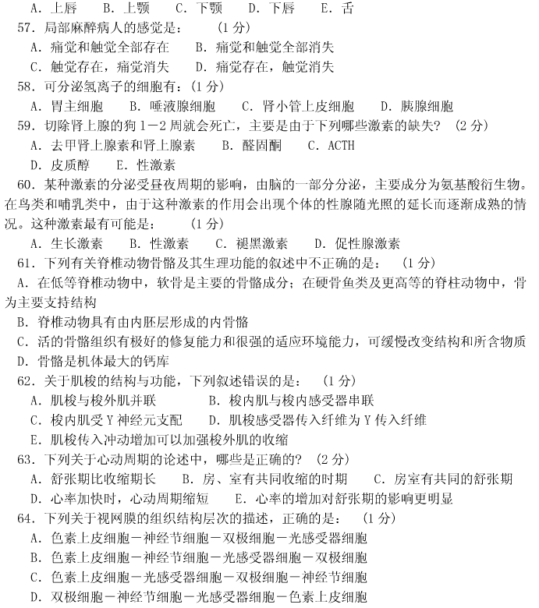

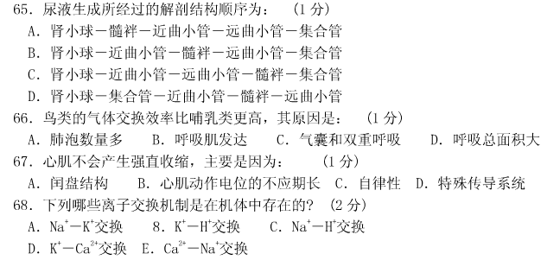



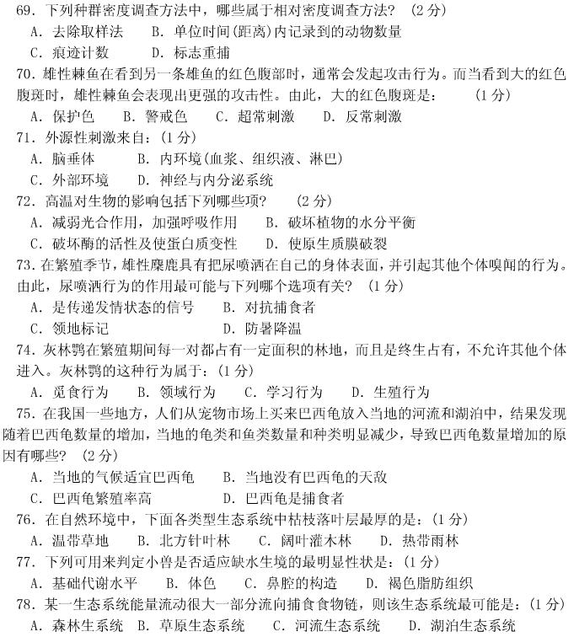

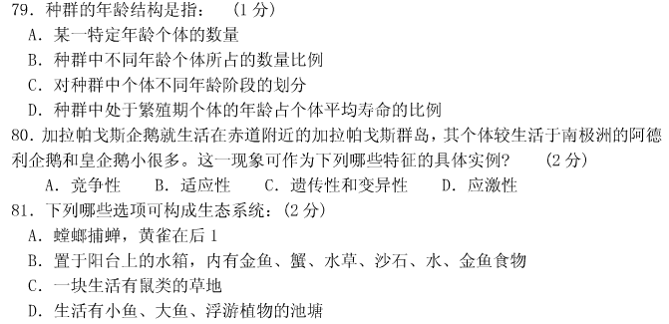



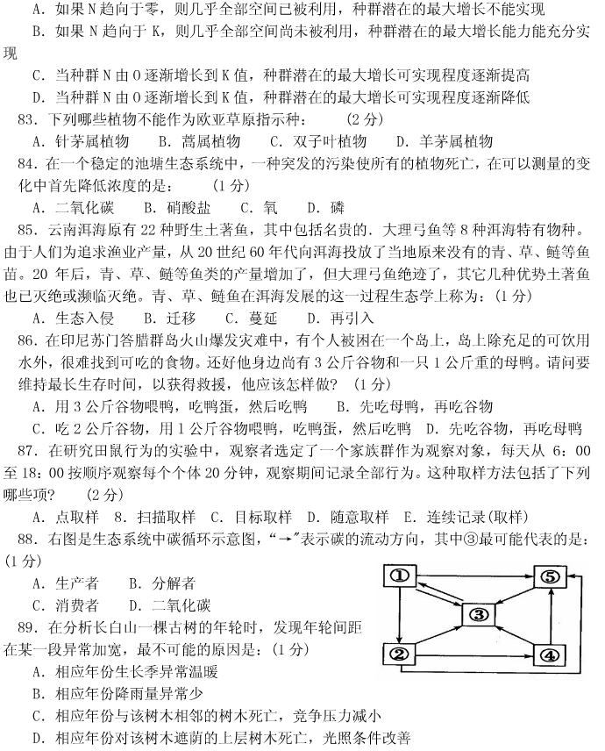

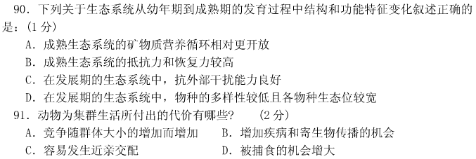



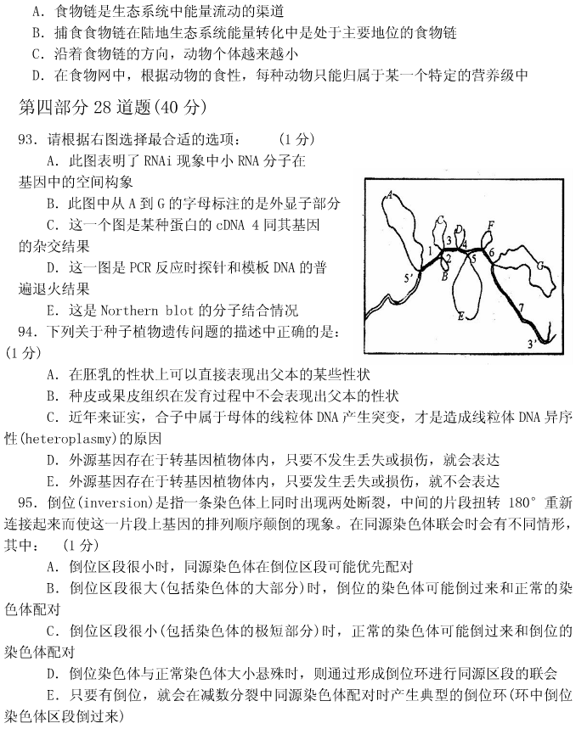

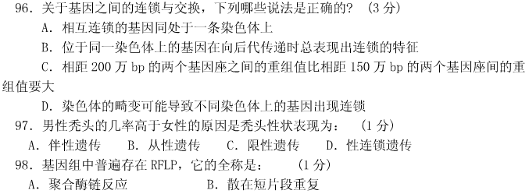

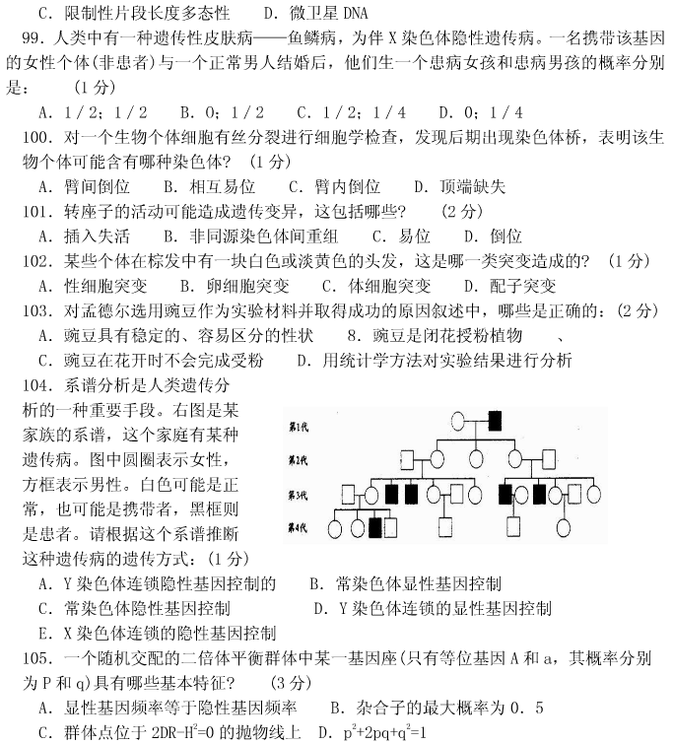

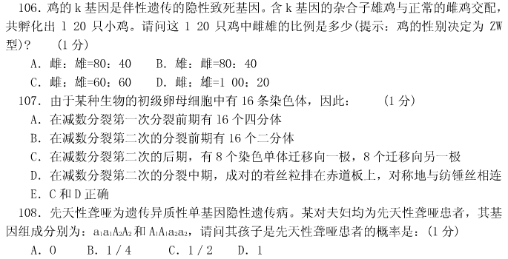

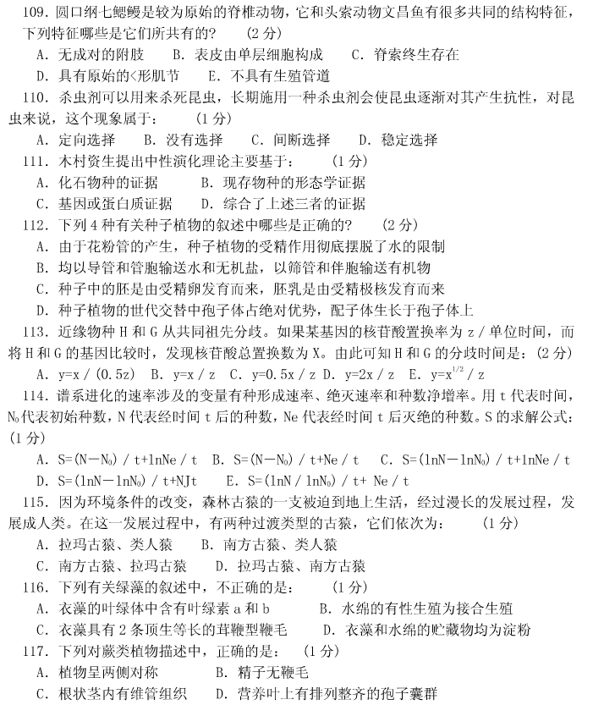

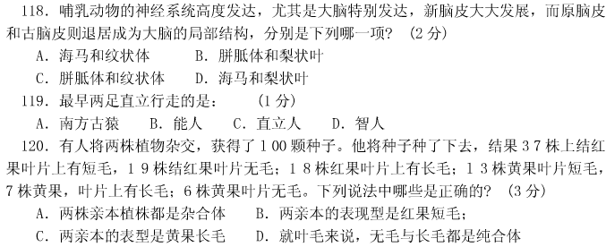

2011年全国中学生生物学联赛答案

|  |  |  |  |  |  |  |  |  |  |  |  |  |
| --- | --- | --- | --- | --- | --- | --- | --- | --- | --- | --- | --- | --- |
| 第一部分 | | | | | | | | | | | | |
| 题号 | 1 | 2 | 3 | | 4 | 5 | 6 | 7 | 8 | 9 | | 10 |
| 答案 | A | A | ABC | | C | D | ABCE | B | D | C | | E |
|  | | | | | | | | | | | | |
| 题号 | 11 | 12 | 13 | | 14 | 15 | 16 | 17 | 18 | | 19 | 20 |
| 答案 | ABD | BE | D | | B | B | B | B | ABCDE | | A | BCD |
|  | | | | | | | | | | | | |
| 题号 | 21 | 22 | 23 | | 24 | 25 | 26 | 27 | 28 | 29 | | 30 |
| 答案 | C | B | A | | C | C | ACD | B | D | B | | AD |
| 第二部分 | | | | | | | | | | | | |
| 题号 | 31 | 32 | | 33 | 34 | 35 | 36 | 37 | 38 | 39 | | 40 |
| 答案 | C | BCD | | A | C | B | AC | B | C | AD | | A |
|  | | | | | | | | | | | | |
| 题号 | 41 | 42 | 43 | | 44 | 45 | 46 | 47 | 48 | 49 | | 50 |
| 答案 | A | B | BD | | D | B | A | A | B | AD | | B |
|  | | | | | | | | | | | | |
| 题号 | 51 | 52 | 53 | | 54 | 55 | 56 | 57 | 58 | 59 | | 60 |
| 答案 | ABC | A | B | | C | C | C | C | C | BD | | C |
|  | | | | | | | | | | | | |
| 题号 | 61 | 62 | 63 | | 64 | 65 | 66 | 67 | 68 |  | |  |
| 答案 | B | D | ACDE | | C | B | C | B | ABCE |  | |  |
| 第三部分 | | | | | | | | | | | | |
| 题号 | 69 | 70 | 71 | | 72 | 73 | 74 | 75 | 76 | 77 | | 78 |
| 答案 | BC | C | C | | ABC | A | B | ABC | B | C | | D |
|  | | | | | | | | | | | | |
| 题号 | 79 | 80 | 81 | | 82 | 83 | 84 | 85 | 86 | 87 | | 88 |
| 答案 | B | BC | BCD | | D | BCD | **C** | A | B | BCE | | D |
|  | | | | | | | | | | | | |
| 题号 | 89 | 90 | 91 | | 92 |  |  |  |  |  | |  |
| 答案 | B | D | ABC | | A |  |  |  |  |  | |  |
| 第四部分 | | | | | | | | | | | | |
| 题号 | 93 | 94 | 95 | | 96 | 97 | 98 | 99 | 100 | 101 | | 102 |
| 答案 | C | A | B | | AD | B | C | D | D | ABCD | | C |
|  | | | | | | | | | | | | |
| 题号 | 103 | 104 | 105 | | 106 | 107 | 108 | 109 | 110 | 111 | | 112 |
| 答案 | ABD | E | BD | | B | C | A | ACE | A | C | | AD |
|  | | | | | | | | | | | | |
| 题号 | 113 | 114 | 115 | | 116 | 117 | 118 | 119 | 120 |  | |  |
| 答案 | C | D | D | | C | **C** | D | A | ABD |  | |  |