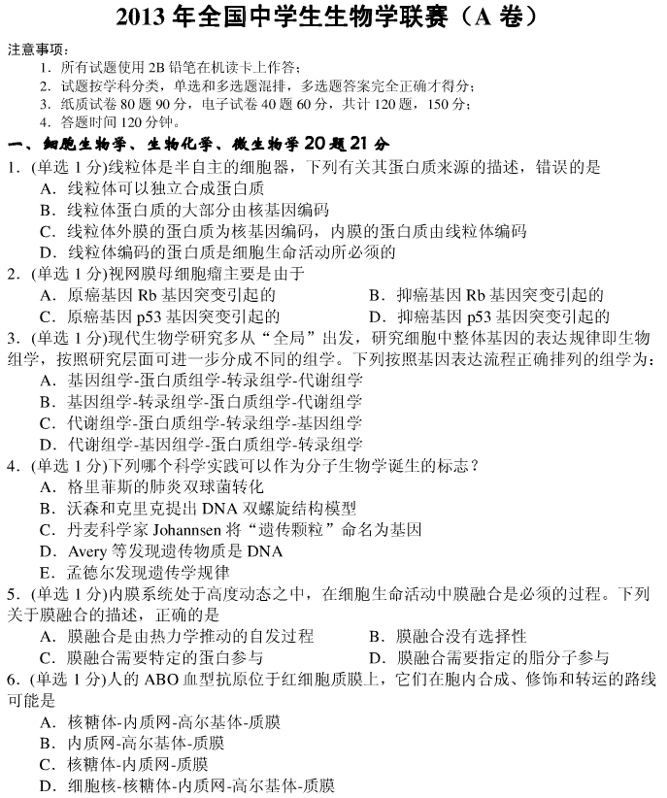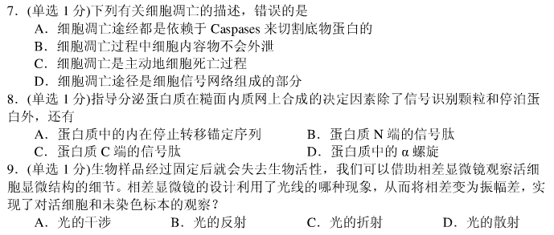
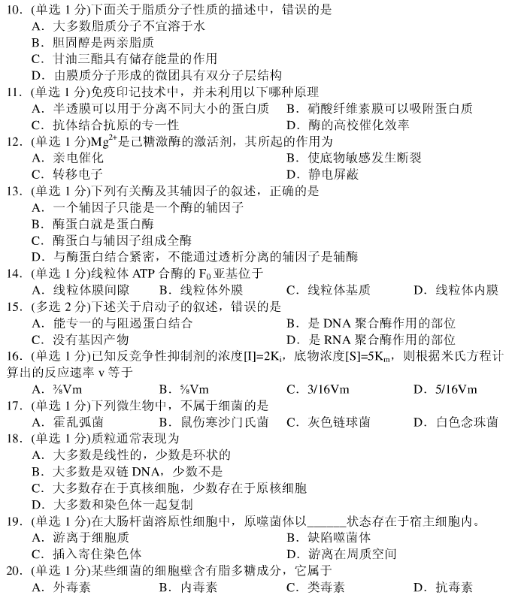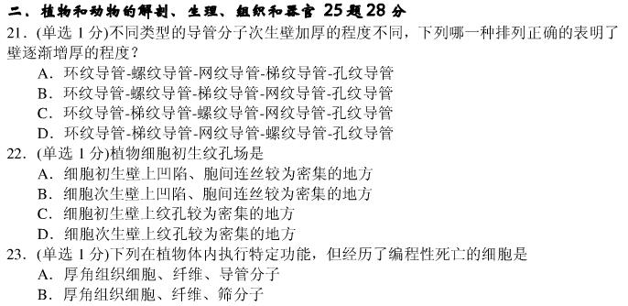
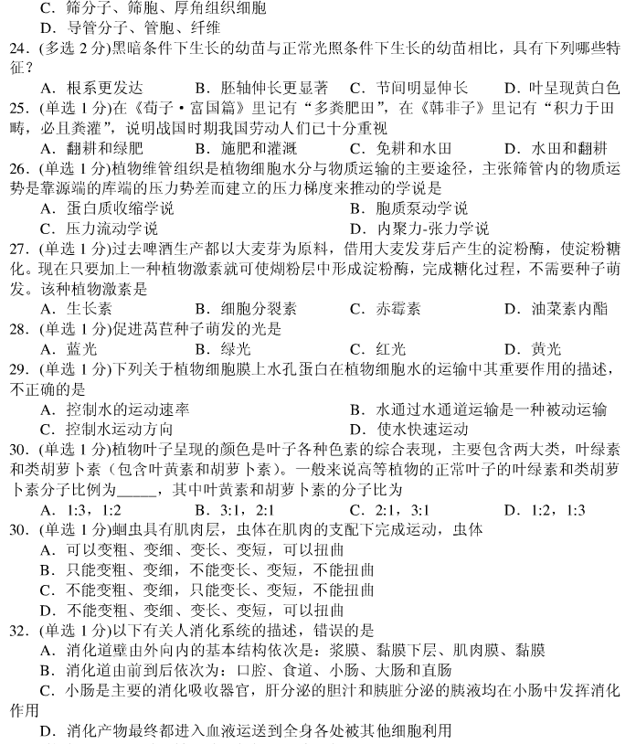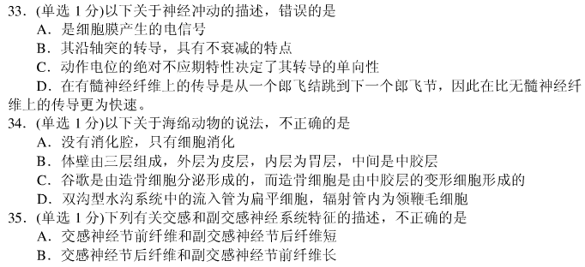
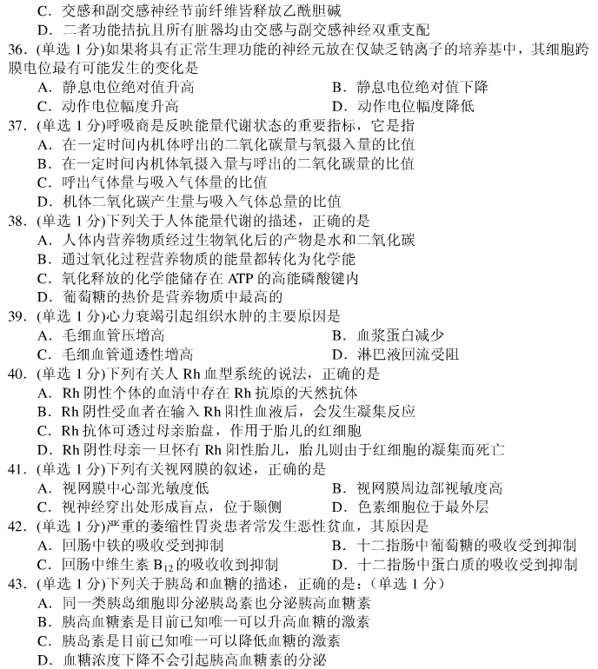
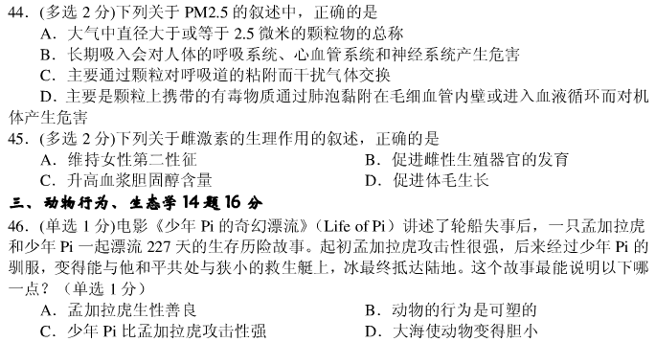
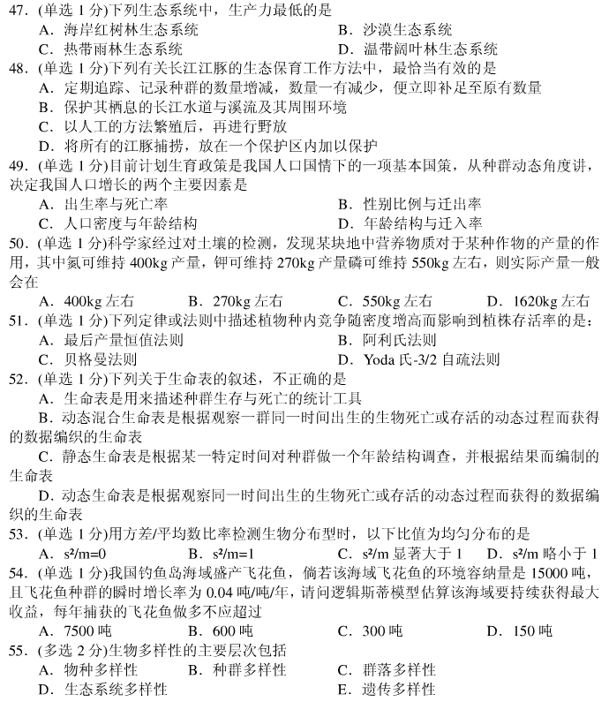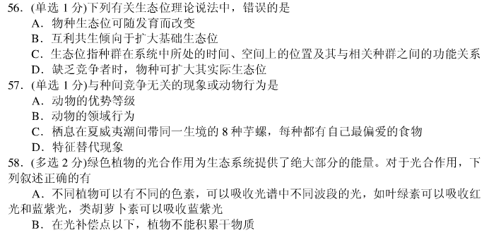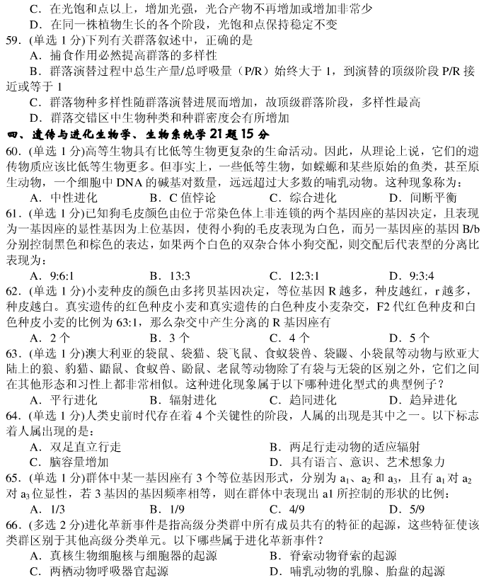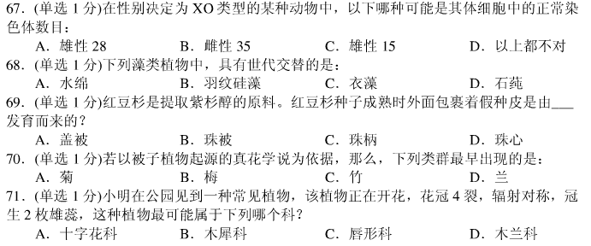
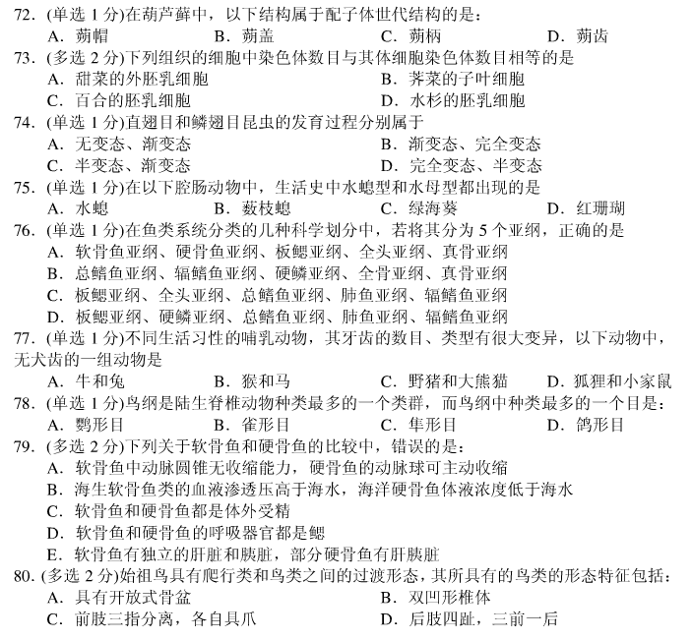

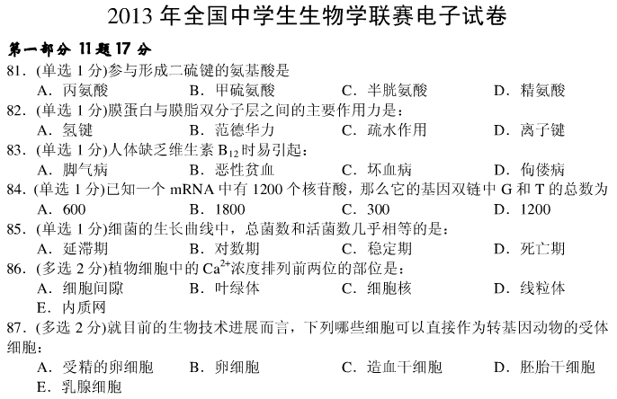
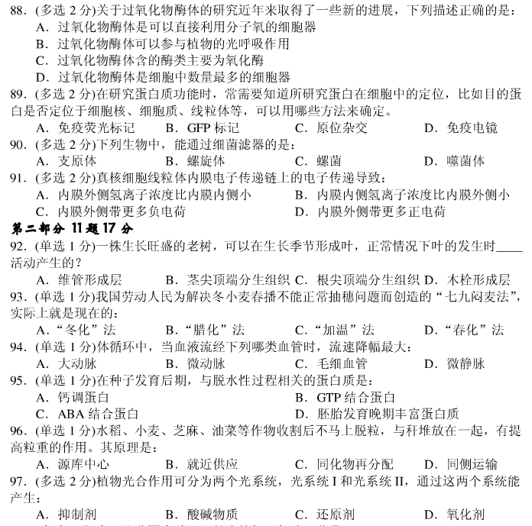
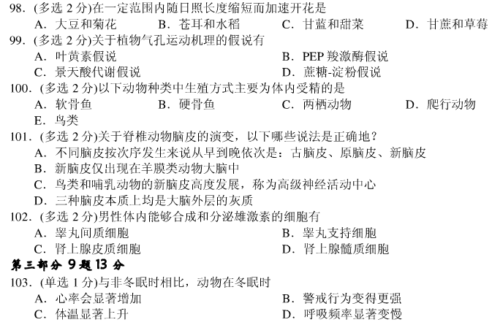
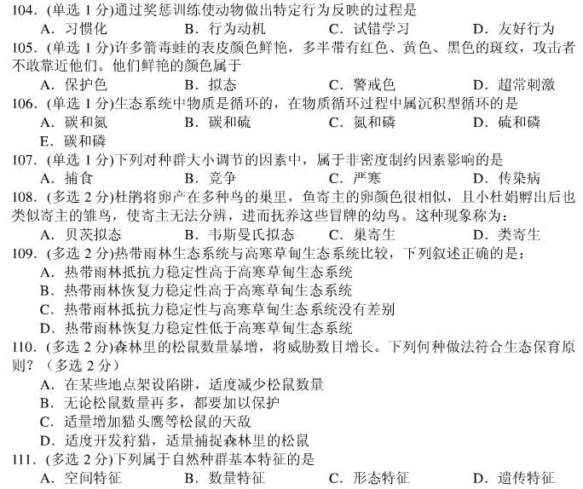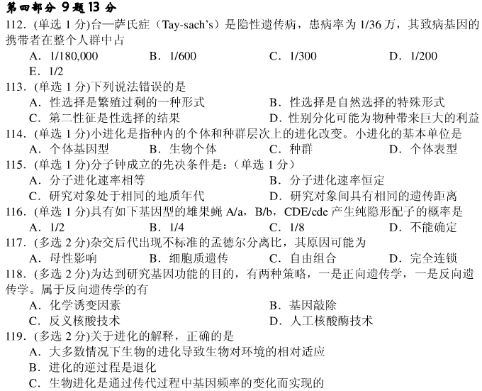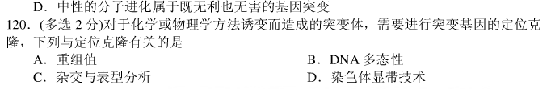

2013年全国中学生生物学联赛答案（A卷）
1 | 2 | 3 | 4 | 5 | 6 | 7 | 8 | 9 | 10
C | B | B | B | C | A | A | B | A | D
11 | 12 | 13 | 14 | 15 | 16 | 17 | 18 | 19 | 20
A | D | C | D | AB | D | D | B | C | B
21 | 22 | 23 | 24 | 25 | 26 | 27 | 28 | 29 | 30
B | A | D | BCD | B | C | C | C | C | B
31 | 32 | 33 | 34 | 35 | 36 | 37 | 38 | 39 | 40
D | A | 删除 | B | D | 删除 | A | C | A | C
41 | 42 | 43 | 44 | 45 | 46 | 47 | 48 | 49 | 50
A或D | C | C | BD | AB | B | B | B | A | B
51 | 52 | 53 | 54 | 55 | 56 | 57 | 58 | 59 | 60
D | B | A | D | ADE | B | A | ABC | 删除 | B
61 | 62 | 63 | 64 | 65 | 66 | 67 | 68 | 69 | 70
C | B | A | C | D | ABCD | C | D | 删除 | B
71 | 72 | 73 | 74 | 75 | 76 | 77 | 78 | 79 | 80
B | A | AB | 删除 | B | C | A | B | AC | AD
81 | 82 | 83 | 84 | 85 | 86 | 87 | 88 | 89 | 90
C | B或C | B | D | B | AE | AD | ABC | ABD | AD
91 | 92 | 93 | 94 | 95 | 96 | 97 | 98 | 99 | 100
BD | B | D | B | D | C | BCD | 删除 | AD | ADE
101 | 102 | 103 | 104 | 105 | 106 | 107 | 108 | 109 | 110
AB | AC | D | C | C | D | C | BC | AD | ACD
111 | 112 | 113 | 114 | 115 | 116 | 117 | 118 | 119 | 120
ABD | C | C | C | B | C | ABD | BCD | ACD | ABC

